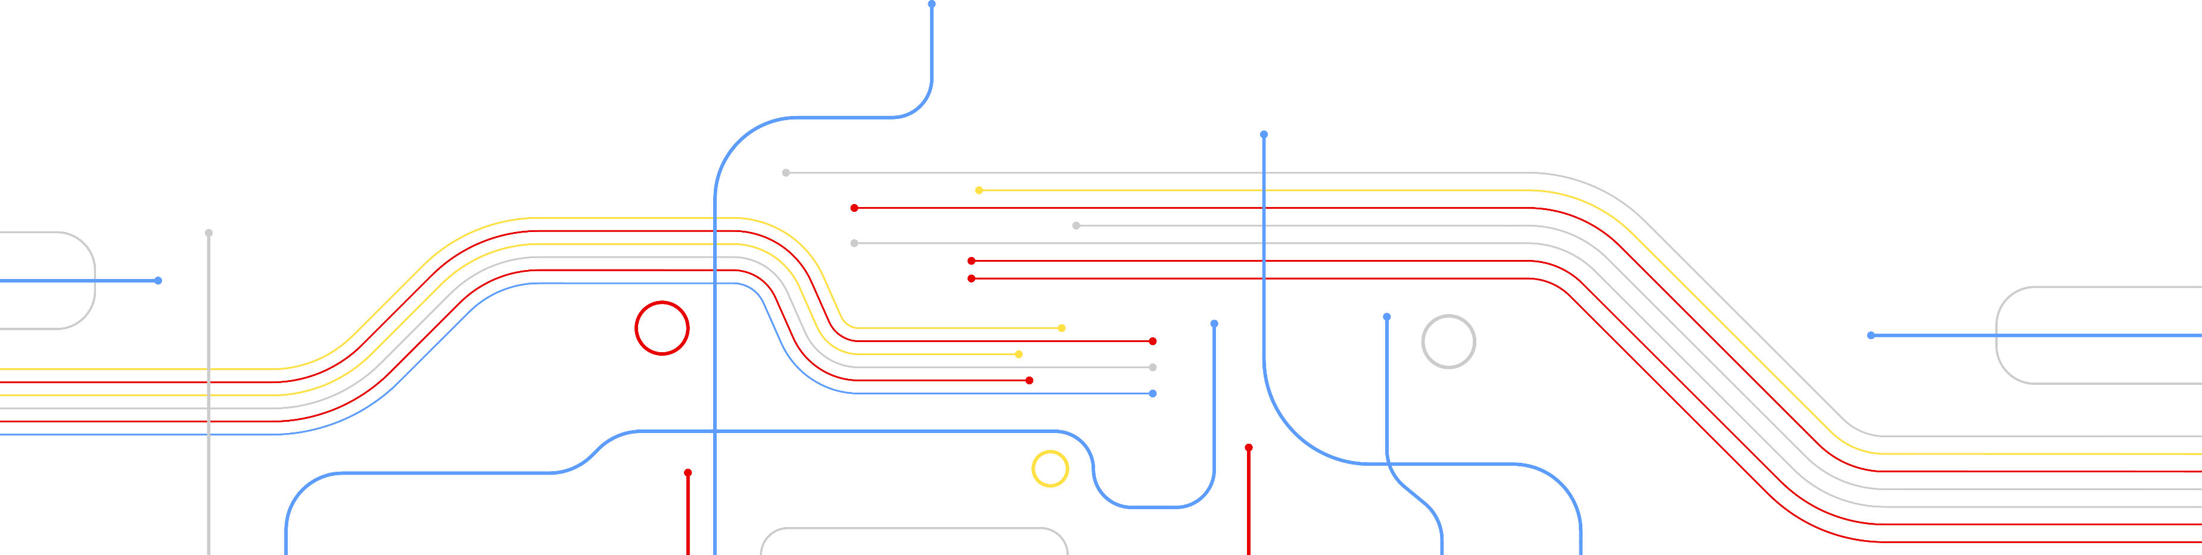

Date :19-22 November 2023
Hyderabad, India
RESULTS
THE TITLE SHOULD BE LARGE AND EASY TO READ
FIRST AUTHOR NAME, SECOND AUTHOR NAME, THIRD AUTHOR NAME
FIRST, SECOND, AND THIRD AUTHOR AFFILIATION, THIRD AUTHOR SECONDARY AFFILIATION
DEPARTMENT, UNIVERSITY, AND/OR
COMPANY LOGOS (OPTIONAL)

If no details to be added, this box/text can be simply deleted

Include a thorough explanation of your method. As much as possible use visual illustrations more than text to capture attention and make it easy to quickly grasp the main concepts.
METHOD / PIPELINE / ALGORITHM
Show the results of your method. If possible, show a comparison between your technique and previous work. You may want to compare quality, speed, and/or ease of use.
Optionally, you may also describe the limitations of your method and indicate directions of future work.

REFERENCES

References may be in small text but should still be readable at full size.

(Optional) Email of Corresponding Author and/or Funding Acknowledgement

A FEW SUGGESTIONS ABOUT FORMATTING: CLEARLY LABEL AXES AND DIAGRAMS.
AVOID LARGE BLOCKS OF TEXT AND SMALL FONT SIZES (< 30PT).
USE HIGH-RESOLUTION IMAGES, AND USE VECTOR GRAPHICS WHENEVER POSSIBLE.
USE COLORS THAT ARE VERY DIFFERENT IN HUE AND LUMINANCE FOR EASIER DISCRIMINATION.
PRIORITIZE IMPORTANT INFORMATION AND DO NOT INCLUDE NONESSENTIAL INFORMATION.

YOUR APPROACH / SOLUTION

Give a short overview of your method. In particular, clearly describe how your work solves the problem described above and improves upon previous work or the current state of the art.

RELATED WORK / MOTIVATION
For research posters, cite related papers, posters, talks, or existing methods that are highly relevant to your project.

If your contribution is a demonstration, application, or systems poster, describe the current state of the art and its limitations.
These descriptions should be very brief
(1-2 lines each).

FOR EXCELLENT EXAMPLES OF FIGURES AND VISUAL ILLUSTRATIONS, PLEASE SEE THE VLSID.ORG PREVIOUS WEBSITES.
EXAMPLE POSTERS AND ABSTRACTS MAY BE FOUND.

PROBLEM

Concisely explain the problem to be solved and why it is important. Use simple terms that would be accessible to someone outside your ﬁeld of expertise. Include an image or diagram if it would be helpful.

FIGURE PLACEHOLDER

